Software Design and Modeling

Software structure

- Student searches for a book or e-book using the application interface (Frontend)

- Request goes to Backend

- Backend checks the Database for:
- book title
- author
- category
- availability status
- e-book availability

- Backend sends results back to Frontend

- Student selects a book

- Backend retrieves detailed book information from Database

- Frontend displays:
- book details
- availability
- borrowing status

- Student requests to borrow or reserve the book

- Request goes to Backend

- Backend verifies:
- user authentication
- borrowing opportunity
- book availability

- Backend stores borrowing or reservation information in Database

- Database updates book availability status

- Backend sends confirmation message to Frontend

- Student uploads study notes through the application interface (Frontend)

- Request goes to Backend

- Backend stores uploaded notes temporarily in Database with “Pending Review” status

- Admin reviews uploaded notes

- Backend updates note status:
- Approved
- Rejected

- Approved notes become visible to other students through Frontend

- Student accesses e-books

- Backend checks user permissions and e-book availability in Database

- Backend provides secure access to e-book content

- Librarian manages books through the system

- Backend updates:
- book inventory
- borrowing records
- return status
- reservations

- Admin manages users, notes, and system data through the administration panel

Component Diagram

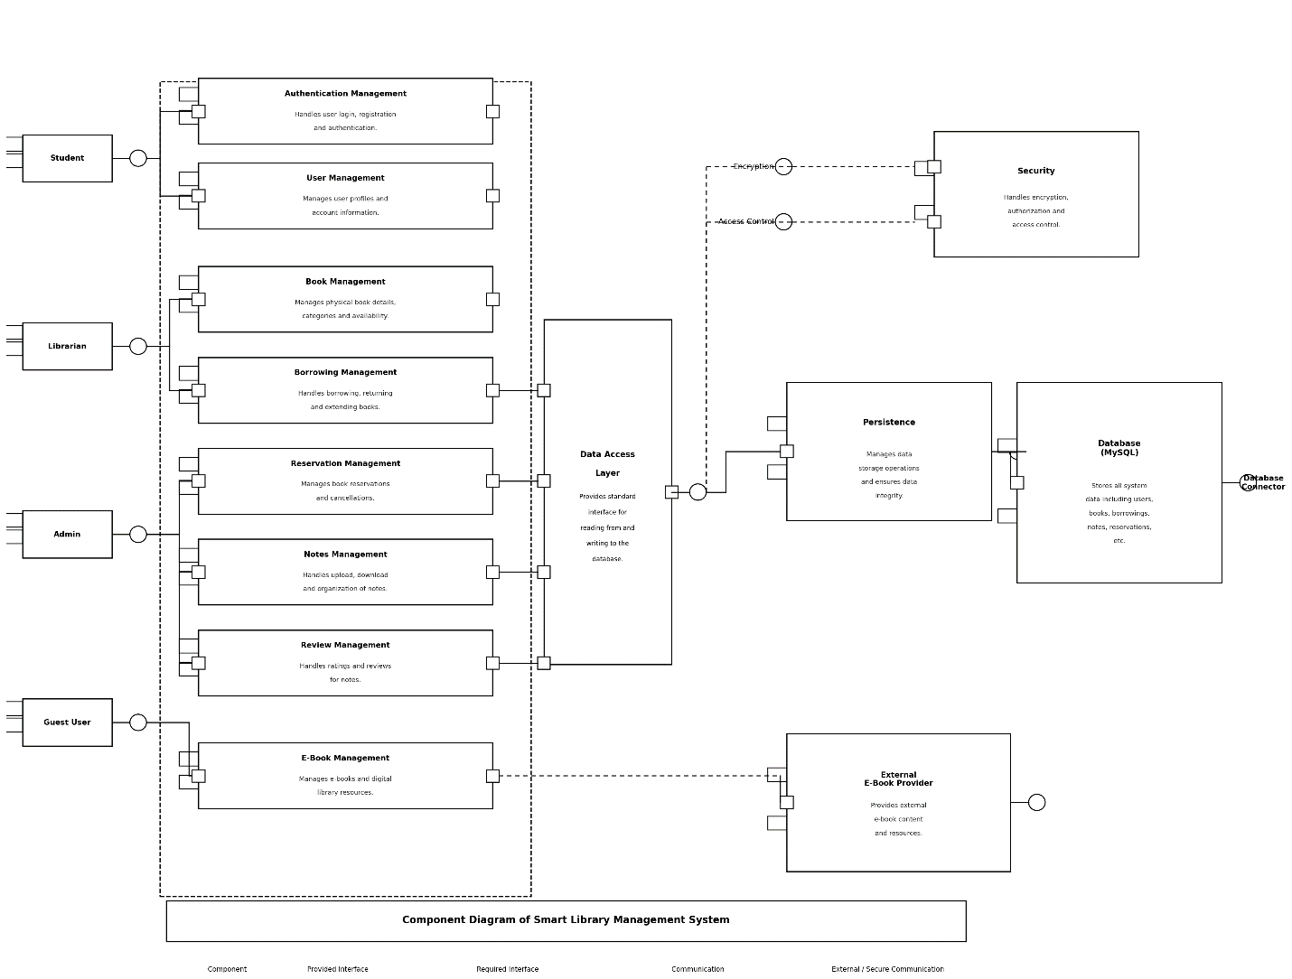

Actors (Left Side):
- Student — Represents a registered student user of the system.
- Librarian — Represents library staff who manage books and borrowing.
- Admin — Represents the system administrator who manages users and content.
- Guest User — Represents an unregistered visitor with limited access.
Components (Middle Part):
- Authentication Management— Handles user login, registration and authentication, meaning it verifies who is accessing the system.
- User Management— Inputs user data in the system.
- Book Management —Provides book records in the database like physical book details, categories and availability.
- Borrowing Management — Handles borrowing transactions, returning and extending books.
- Reservation Management — manages book reservations and cancellations.
- Notes Management — Upload, download and provides organization of notes.
- Review Management — Handles ratings and reviews for notes uploaded by students.
- E-Book Management — Reads and writes e-book records and also communicates externally with the External E-Book Provider through a dashed line.
Right Side:
- Data Access Layer — Provides a standard interface so components can’t communicate with the database directly.
- Security — Handles encryption, authorization and access control. It is connected with data access layer through encryption and access control nodes.
- Persistence — It is responsible for making sure data is correctly saved and not lost or corrupted.
- Database (MySQL) — Stores all system data including users, books, borrowings, notes and reservations. It connects from Persistence and data reaches the database after passing through the persistence layer.
- Database Connector — Provides the interface that links the database to the rest of the system and allows queries to be sent and results to be returned
- External E-Book Provider — Outside third-party digital library that provides additional e-book content and resources.

Class Diagram

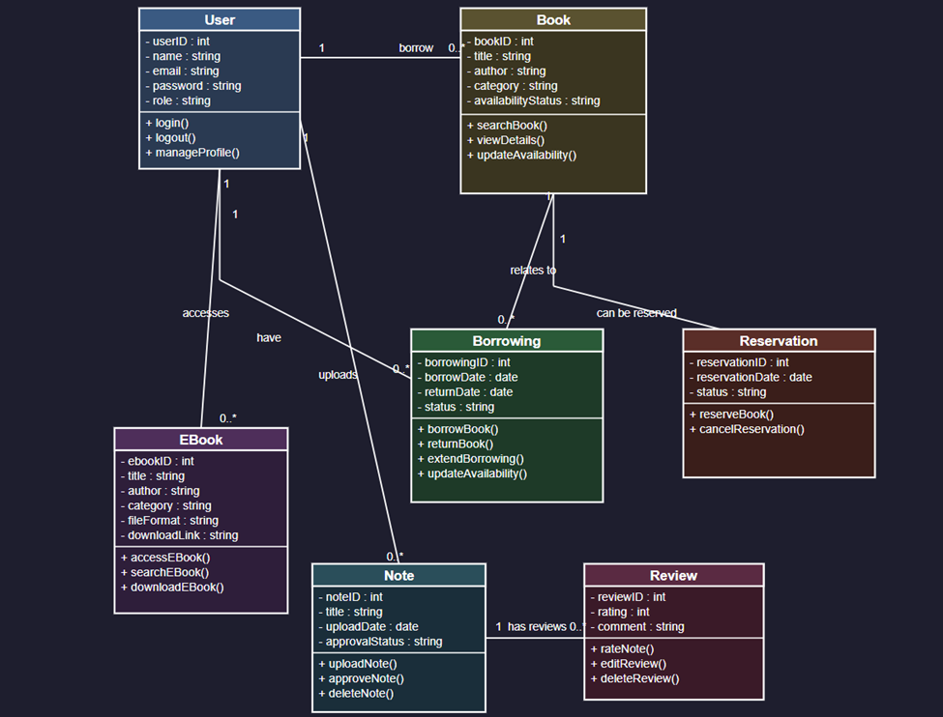

Relationships:
1. User → Book (1 to 0..*): A single User can borrow zero or many Books.
2. User → Borrowing (1 to 0..*): A single User can have zero or many Borrowing records.
3. Book → Borrowing (1 to 0..*): A single Book can relate to zero or many Borrowing records over time.
4. Book → Reservation (1 to 0..*): A single Book can have zero or many Reservations.
5. User → E-Book (1 to 0..*): A single User can access zero or many E-Books.
6. User → Note (1 to 0..*): A single User can upload zero or many Notes.
7. Note → Review (1 to 0..*): A single Note can have zero or many Reviews.
Sequence Diagram
(Search and access books)

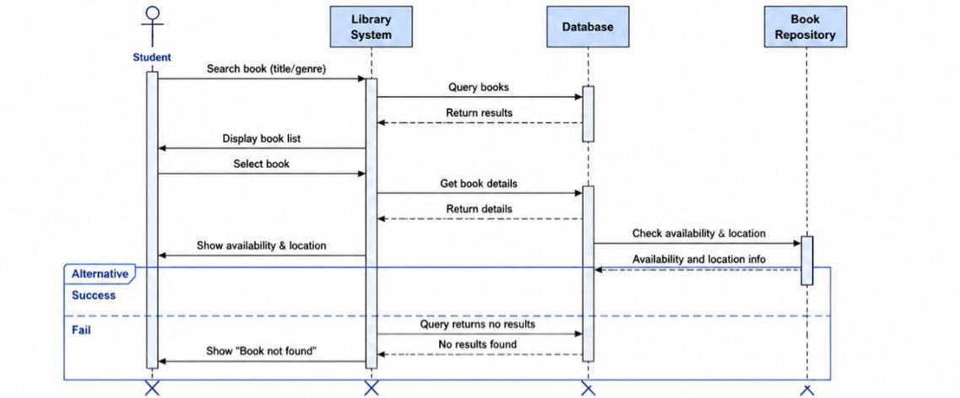

Sequence Diagram
(Upload and access notes)

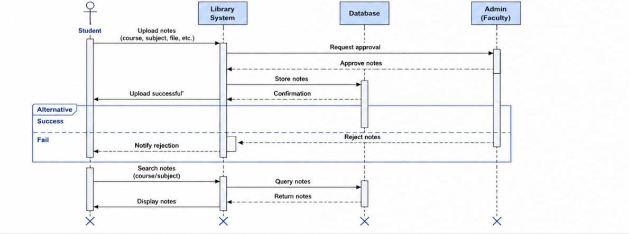

Use Case Diagram

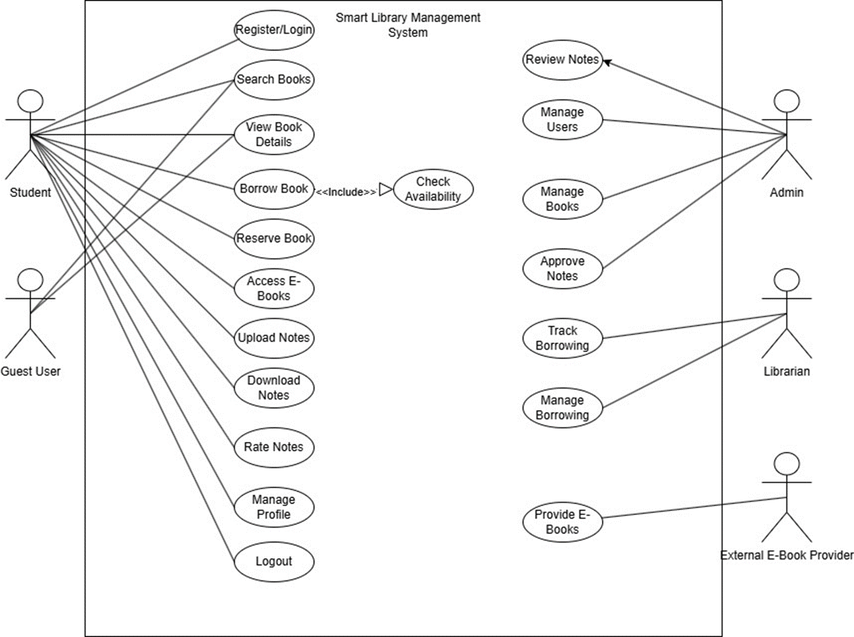

Activity Diagram

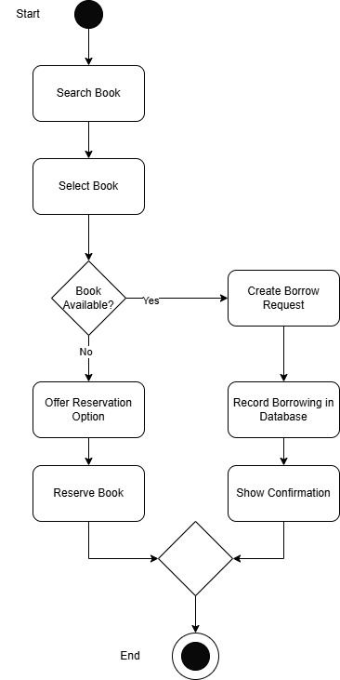
State Diagram
(Book)

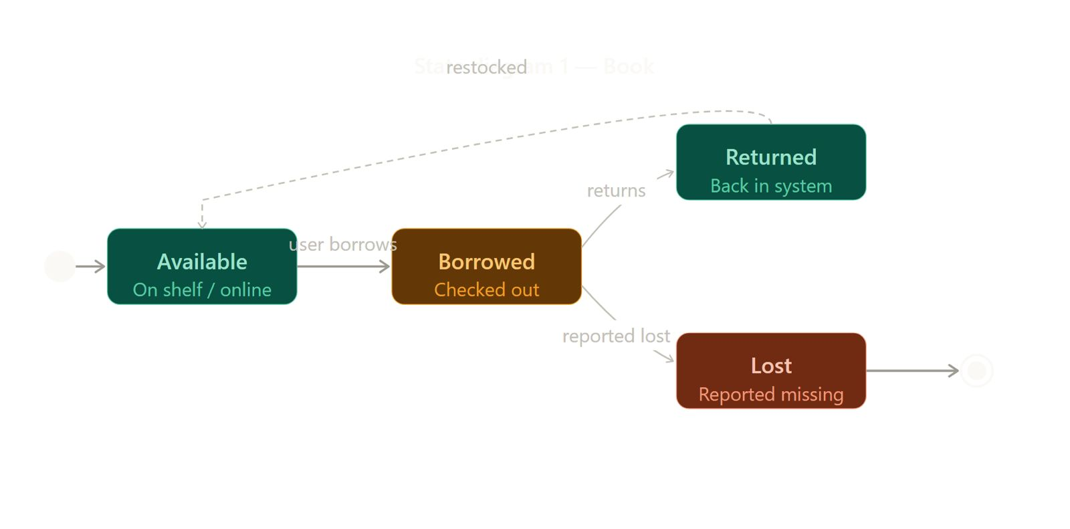

State Diagram
(Student Notes)

